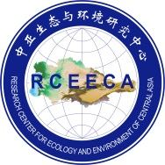 | 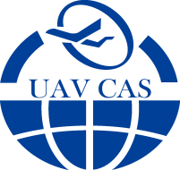 | 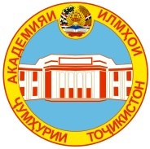
THE INTERNATIONAL SCIENTIFIC AND PRACTICAL CONFERENCE
« TECHNOLOGY AND APPLICATION OF UNNAMED AIRCRAFT VEHICLE IN
SCIENTIFIC AND PRACTICAL PURPOSES»
Agenda
January 10
10:00-11:00 | Registration
11:00-12:00 | Welcome message | Farhod Rahimi-President National Academy of Sciences of Tajikistan
 | Opening Remarks | Sherali Kabir - Minister of Industry and New Technologies of the Republic of Tajikistan
 |  | Rustam Nazarzoda - Head of the Committee for Emergency Situations and Civil Defense under the Government of Tajikistan
 |  | Chen Xi –President, Xinjiang Branch, Chinese Academy of Sciences, Foreign member of NAST
Group photo
12:30-13:30 | Lunch
13:30-17:00 | Presentation Session
17:00-17:45 | Conference closing
19:00 | Dinner
January 11
07:00-08:00 | Breakfast
08:00-08:40 | Trip from Hotel to aerodrome
09:00-12:00 | Demonstration and flights of UAVs
12:30-13:30 | Lunch
 | Free Time
January 12
08:00 | Check-out from hotel
08:00-08:20 | Departure of participants. Transportation from Hotel to airport

